Name: Astha Arpit Bhatt

Enrollment: 196140316006

**Write a simple JSP code to print "Hello World".**

<%@page contentType="text/html" pageEncoding="UTF-8"%>

<!DOCTYPE html>

<html>

<head>

<meta http-equiv="Content-Type" content="text/html; charset=UTF-8">

<title>Hello</title>

</head>

<body>

<%= "Hello World!" %>

</body>

</html>

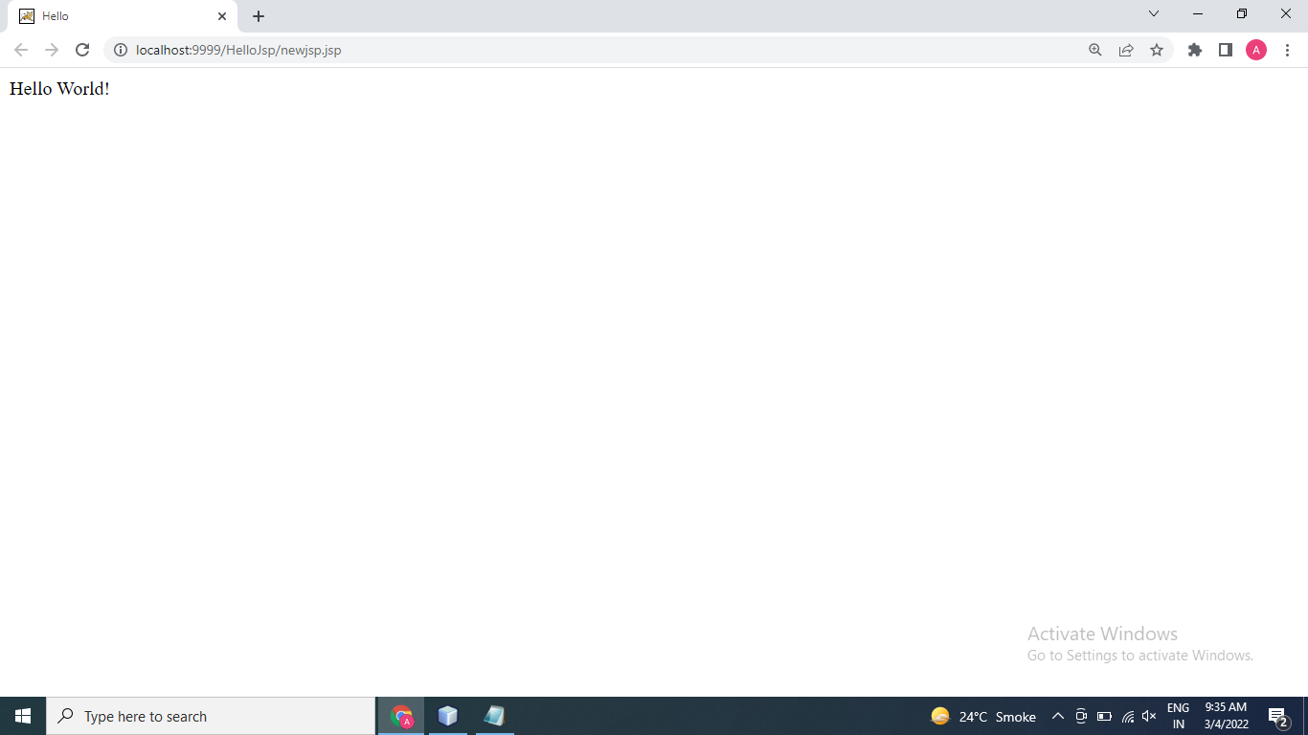

**Write JSP code to determine how many times the visitor has loaded the page.**

<%@page contentType="text/html" pageEncoding="UTF-8"%>

<!DOCTYPE html>

<html>

<head>

<meta http-equiv="Content-Type" content="text/html; charset=UTF-8">

<title>My First JSP Page</title>

</head>

<%!

int count=0;

int getCount()

{

return (++count);

}

%>

<body>

Page count is:

<% out.println(getCount()); %>

</body>

</html>

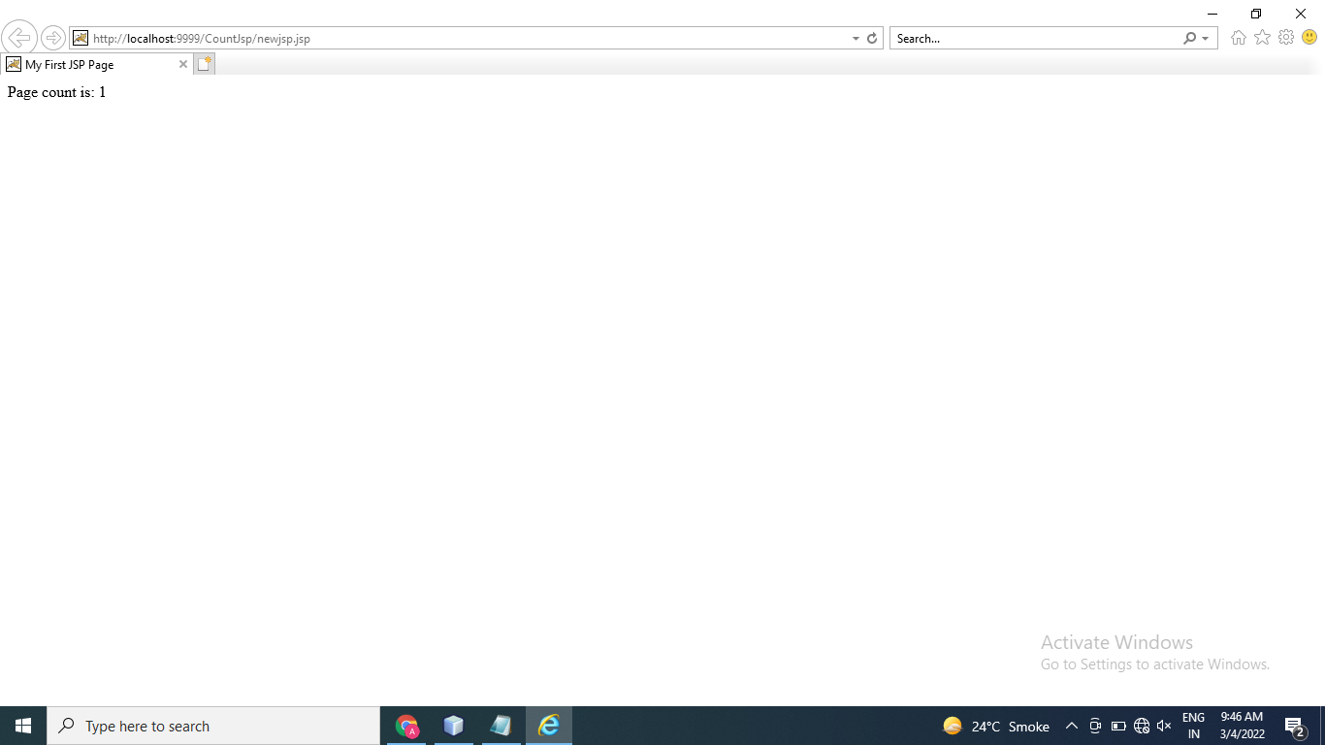

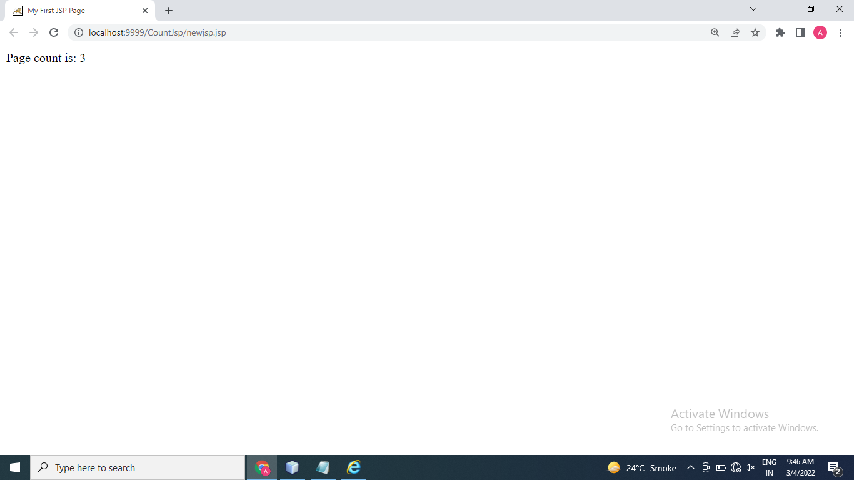

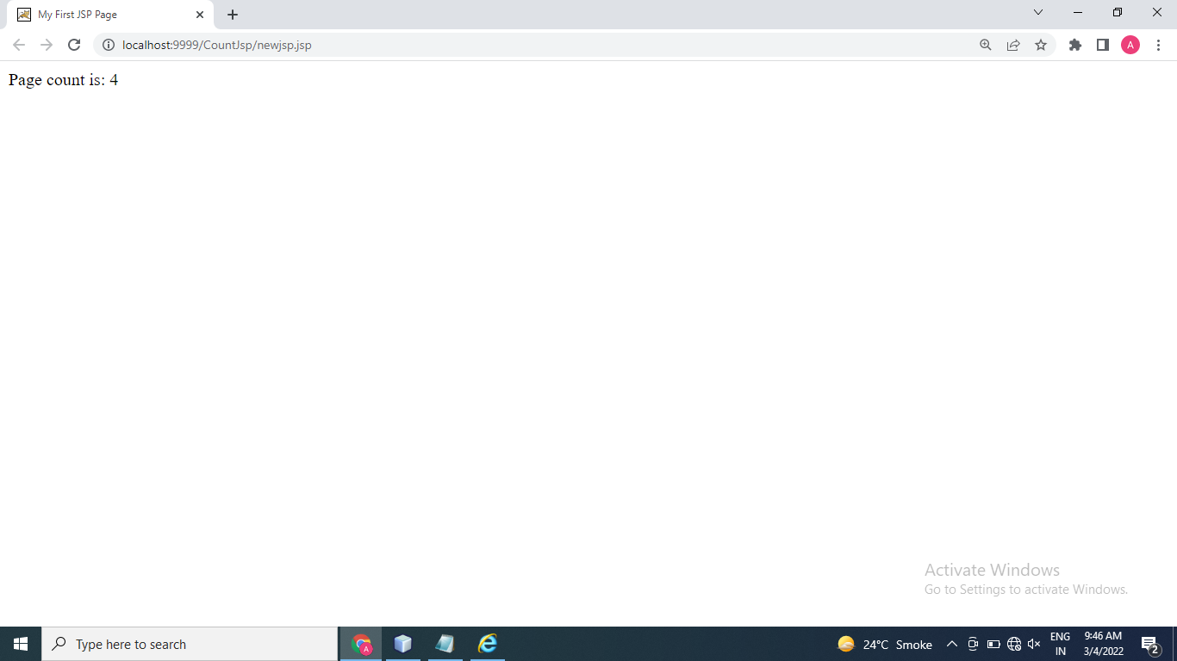

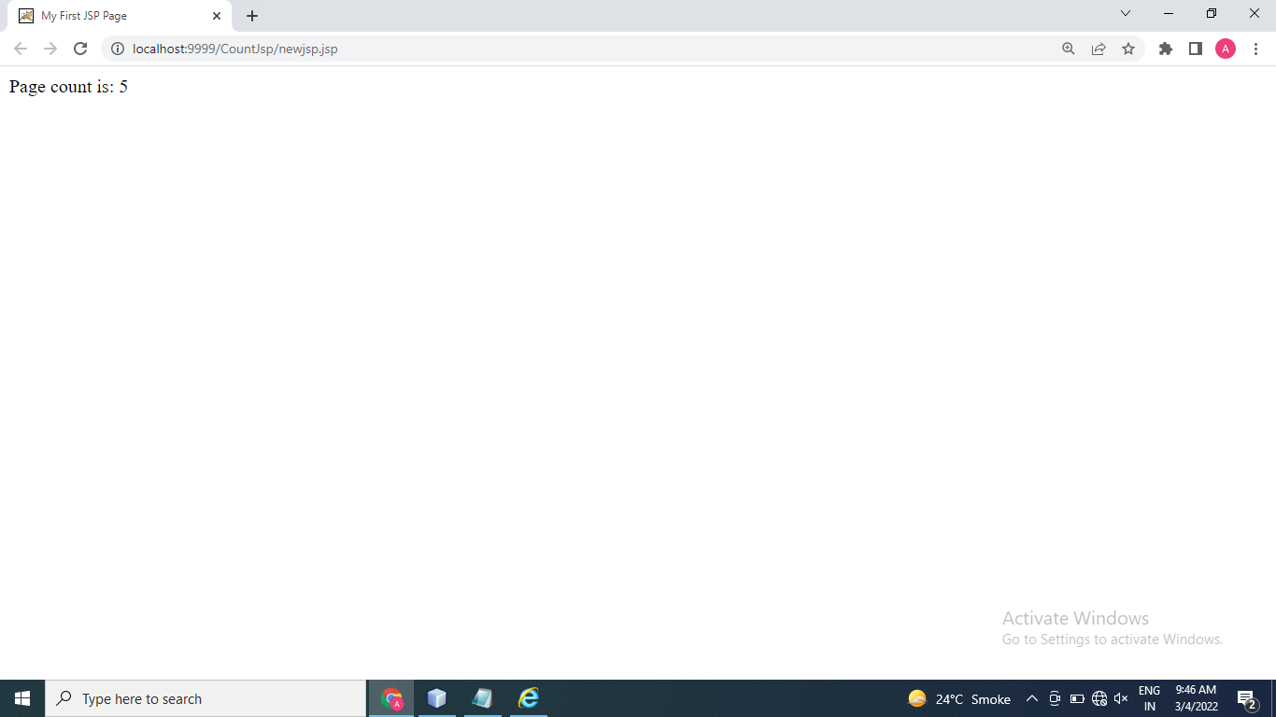

Thanks mam!!